**Experiment 25**

**Lab Book:**



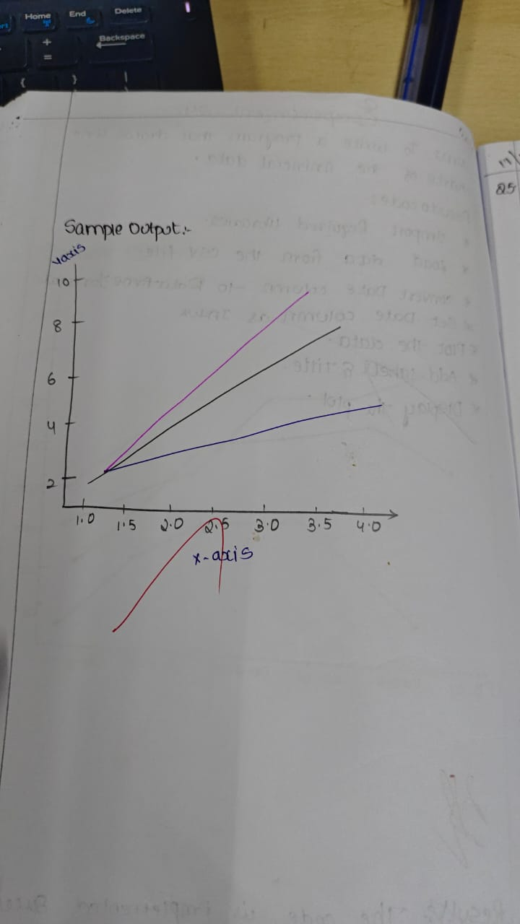

**Code**

import matplotlib.pyplot as plt

x = [1, 2, 3, 4, 5]

y1 = [2, 4, 6, 8, 10]

y2 = [1, 3, 5, 7, 9]

y3 = [2, 3, 4, 5, 6]

plt.plot(x, y1, color='red', linewidth=2, label='Line 1')

plt.plot(x, y2, color='blue', linewidth=3, label='Line 2')

plt.plot(x, y3, color='green', linewidth=4, label='Line 3')

plt.legend()

plt.title('Multiple Lines with Different Properties')

plt.xlabel('X-axis')

plt.ylabel('Y-axis')

plt.show()

**Sample Output**

